**SEGMENT 1 : DATABASE- TABLE COLUMNS AND RELATIONSHIPS**

1. Identify the tables in the database and their respective columns:

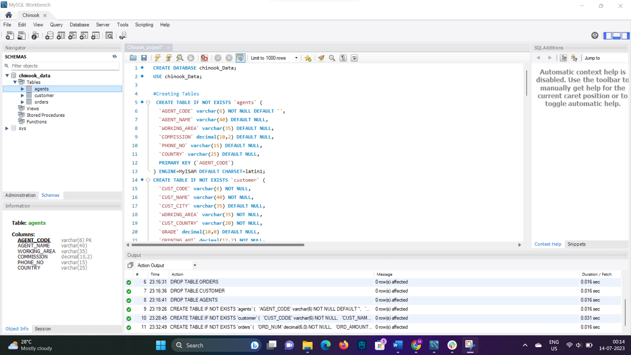

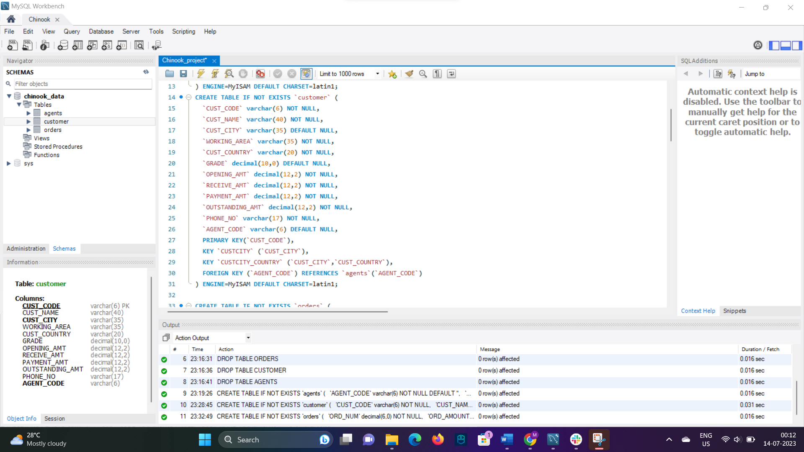

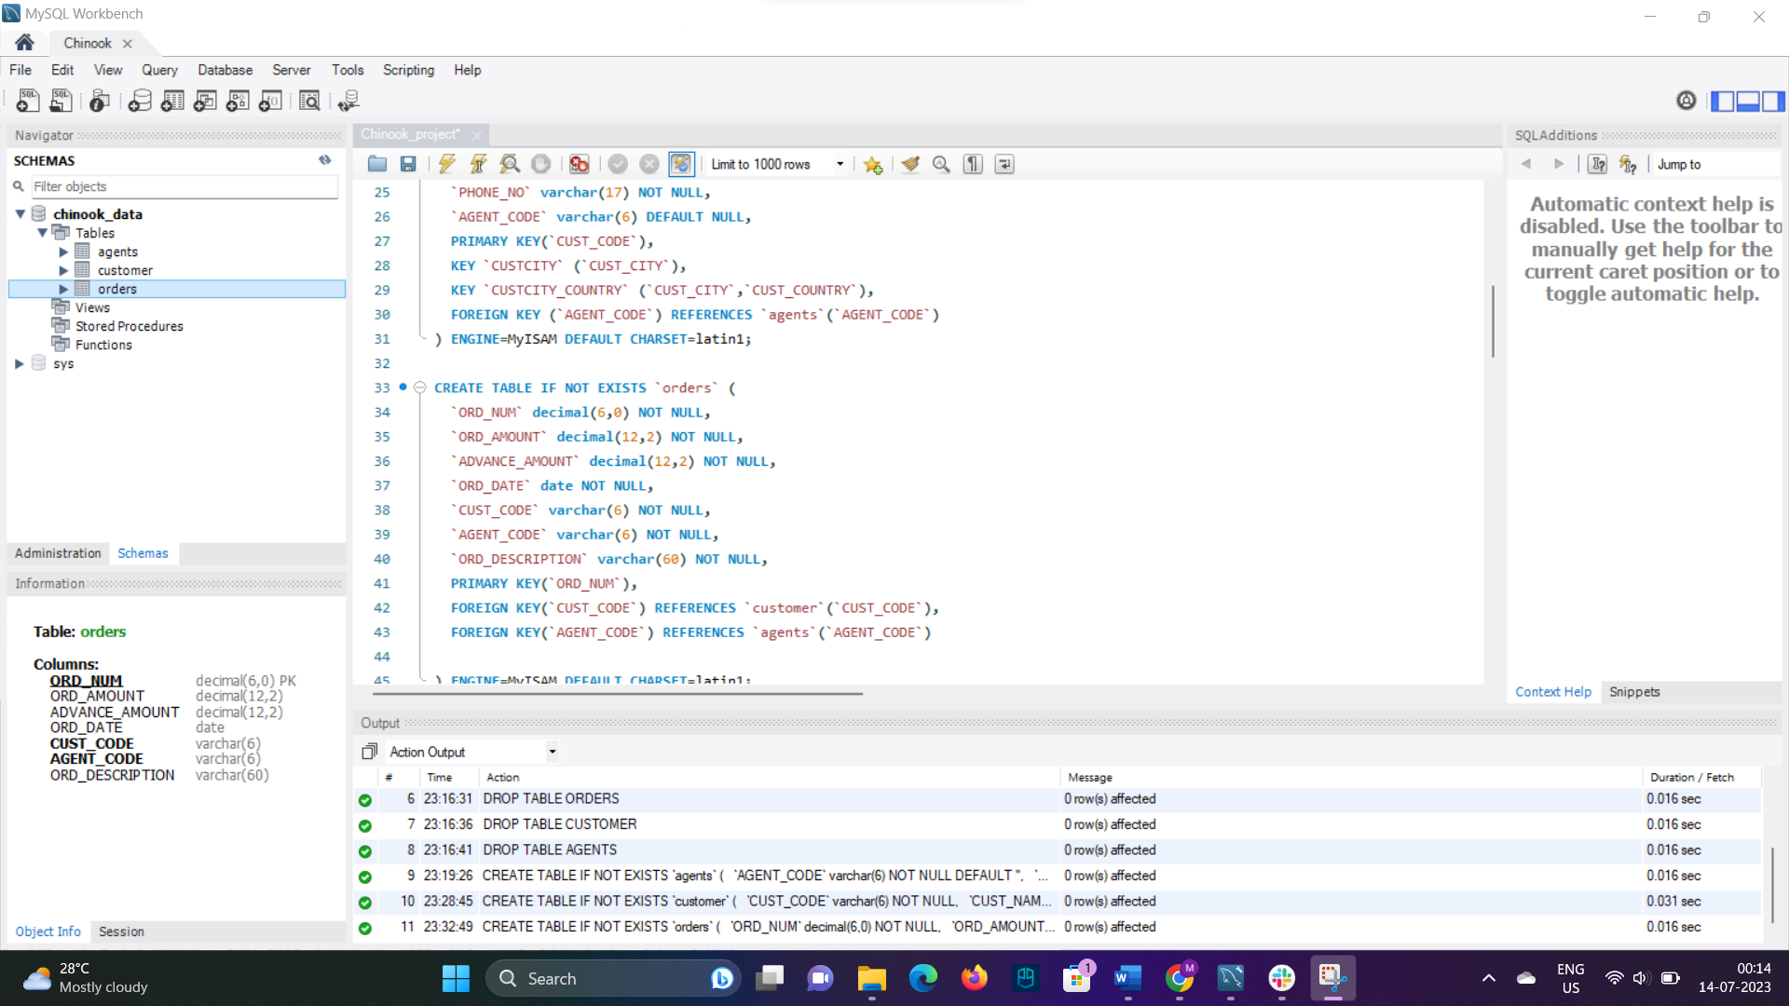

1. Determine the number of records in each table within the schema.

Using count function on primary key so that only unique records count will be done.

For Agent table we have 12 rows:

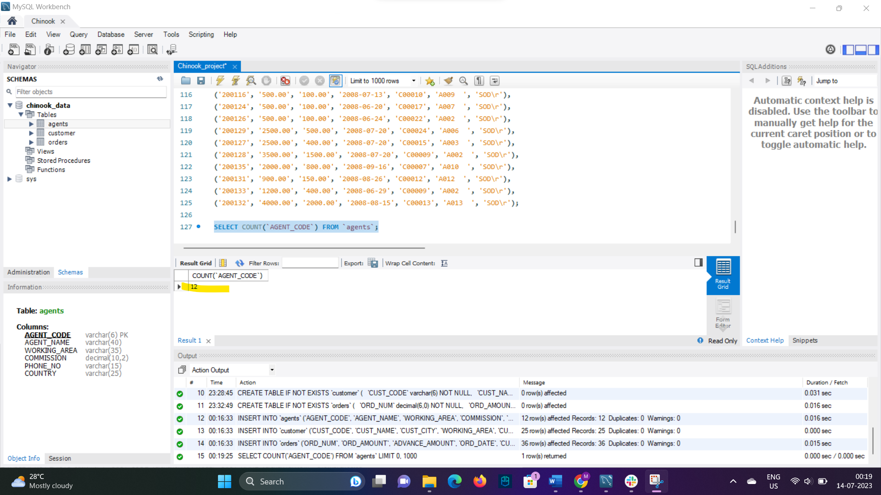

For customer table :

For customer table we have total 25 records,

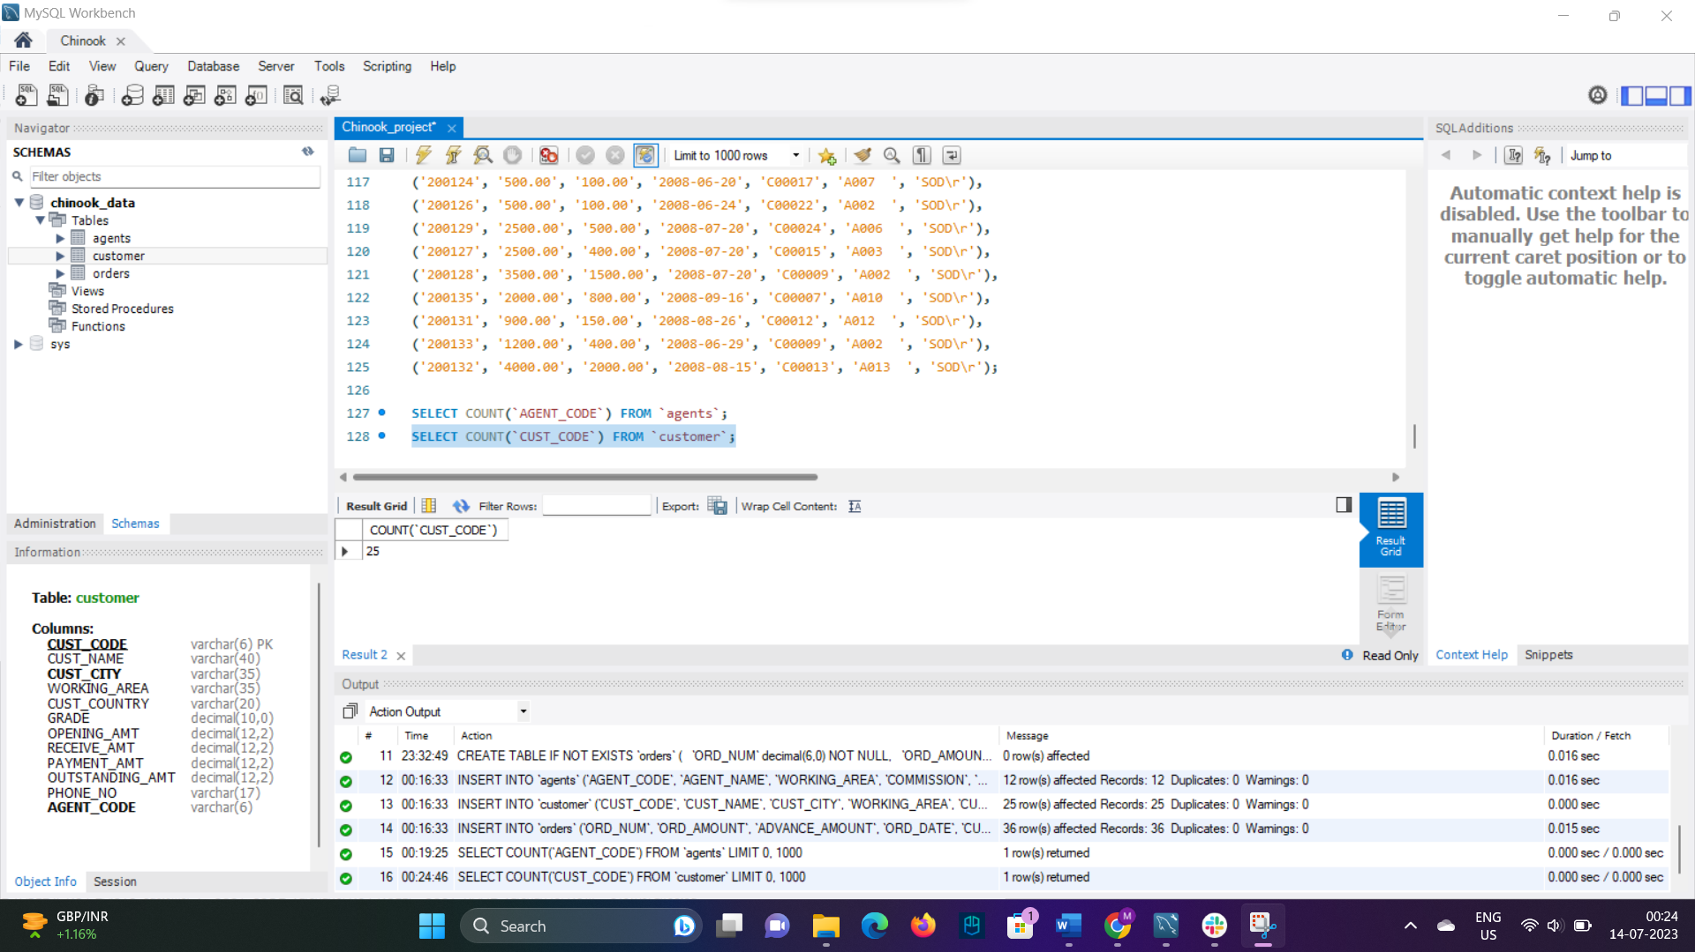

For order table we have total of 36 tables:

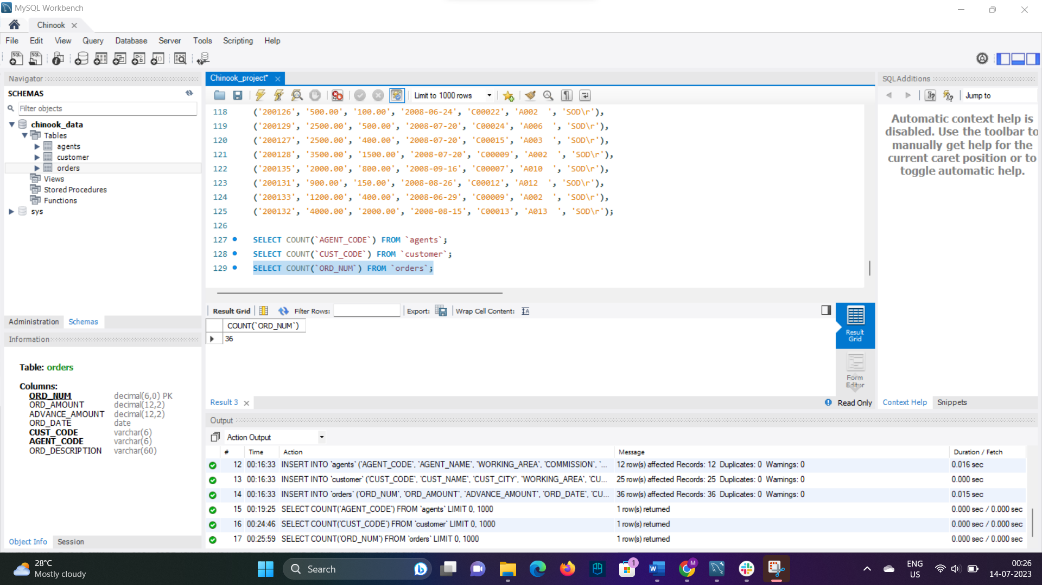

1. Identify and handle any missing or inconsistent values in the dataset.

In Customer table we see there is missing value in country column. We can put NA as default values



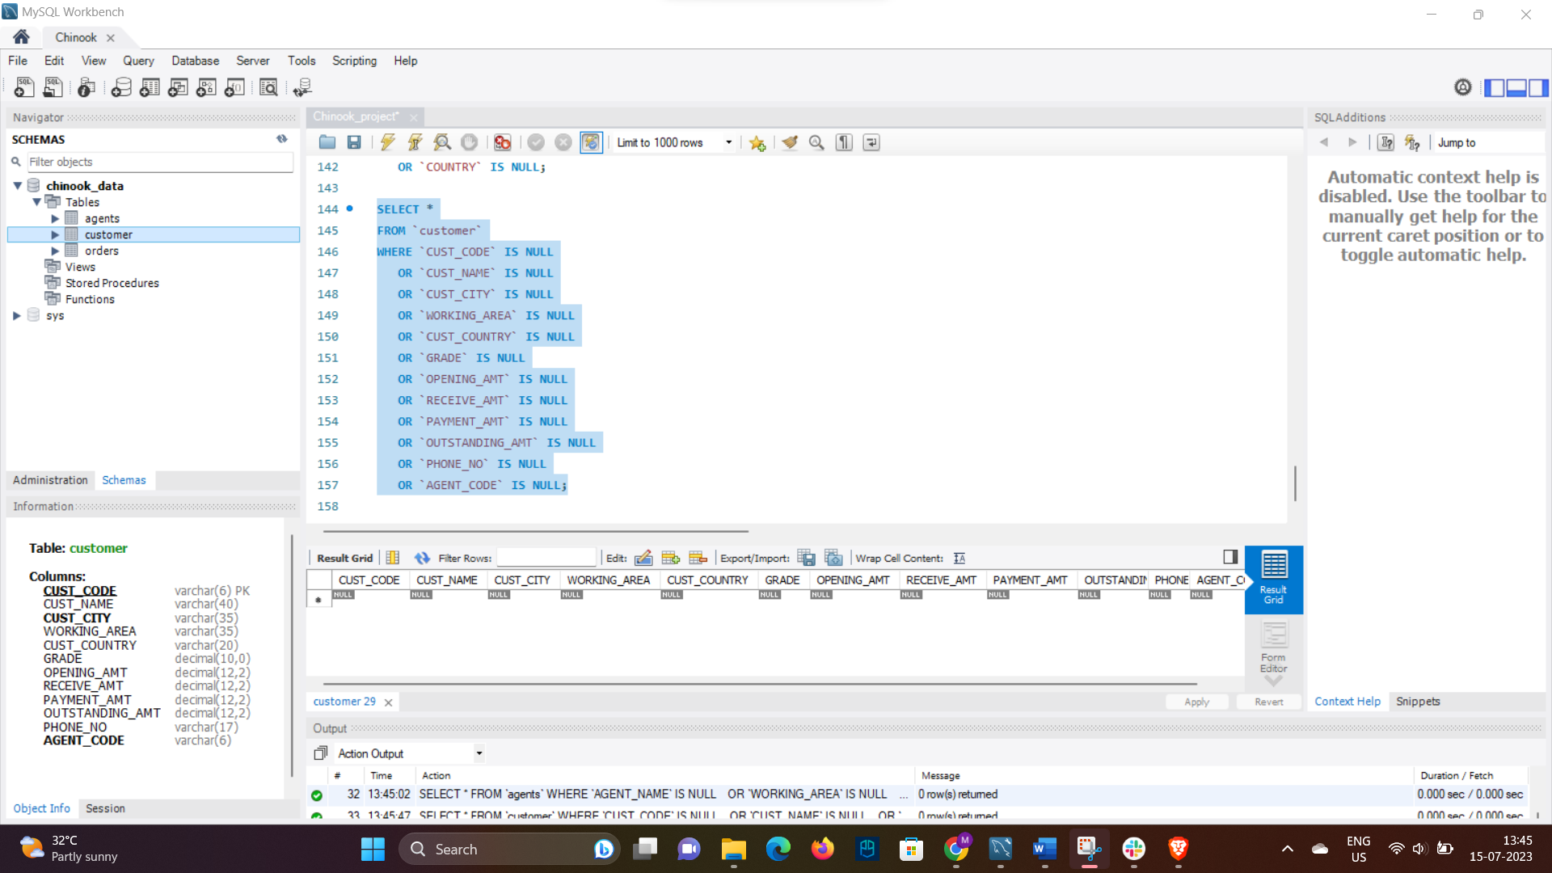



Country column is blank in agent table, we can assume that customer of certain country is handled by that country agent only. Hence, we can update agent column country field same as customer country’s column and relation will be based on agent code from customer table and agent code form agent table.

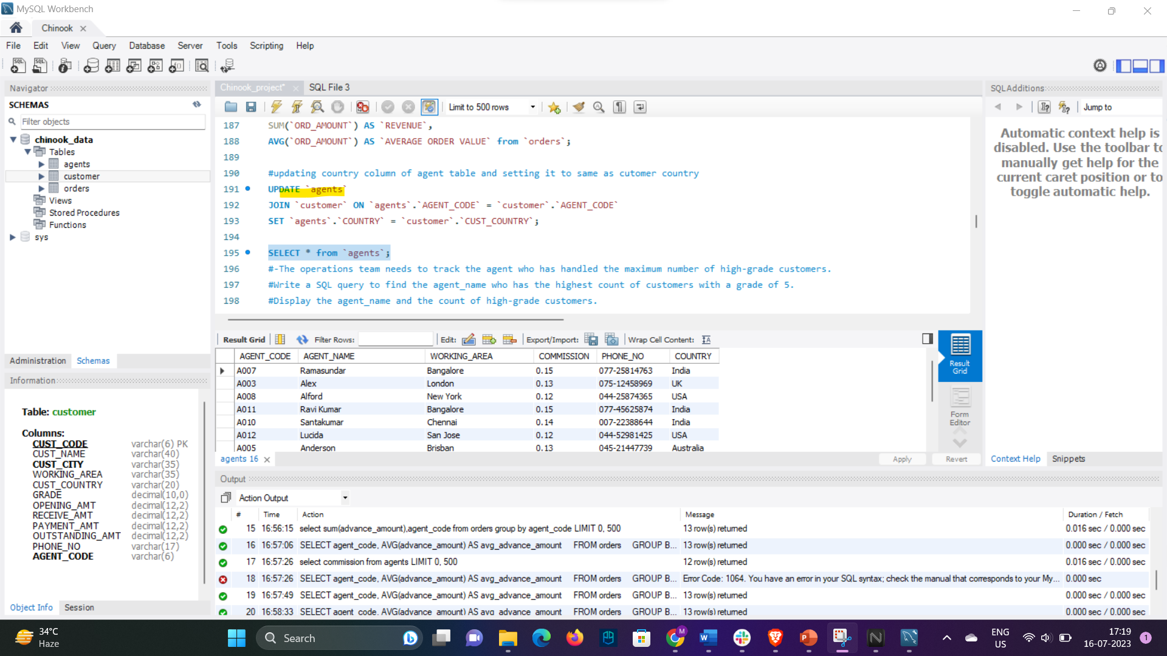

* Analyse the data types of the columns in each table to ensure they are appropriate for the stored data.



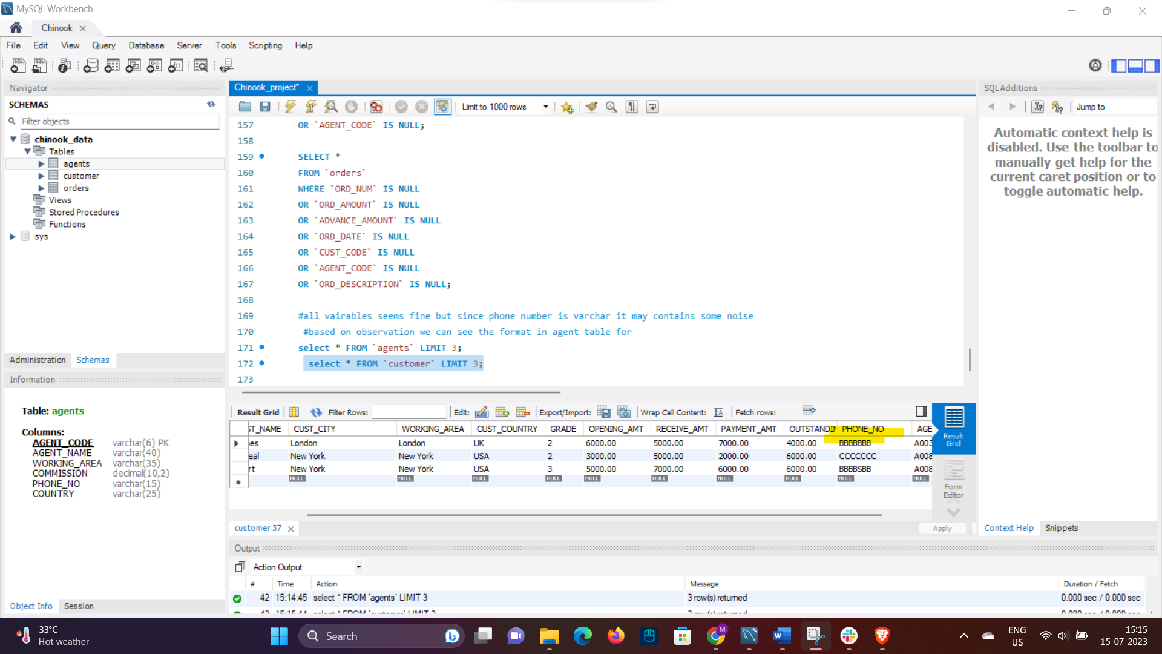

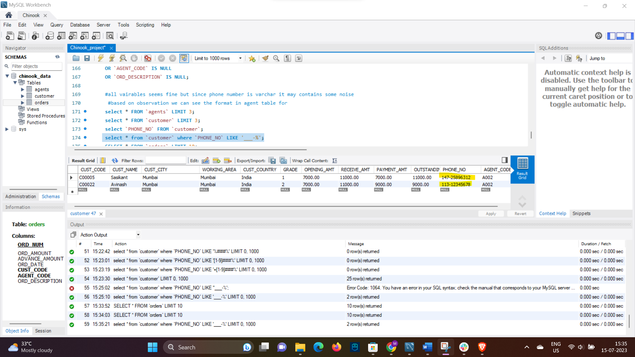

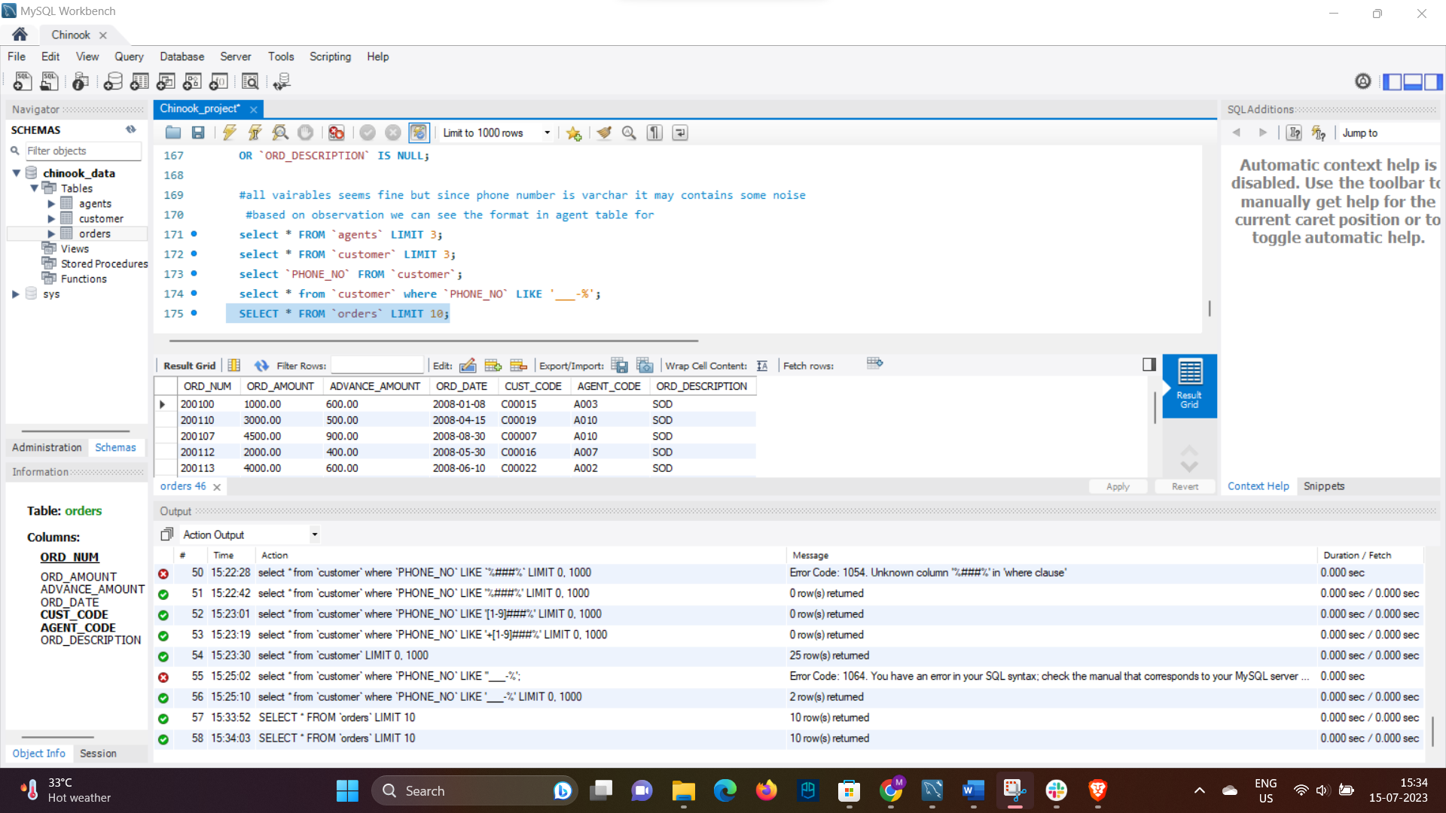

* For handling missing values we can set a default value query so that if while insert query time anything is missing system will replace that some default value if applicable.
* 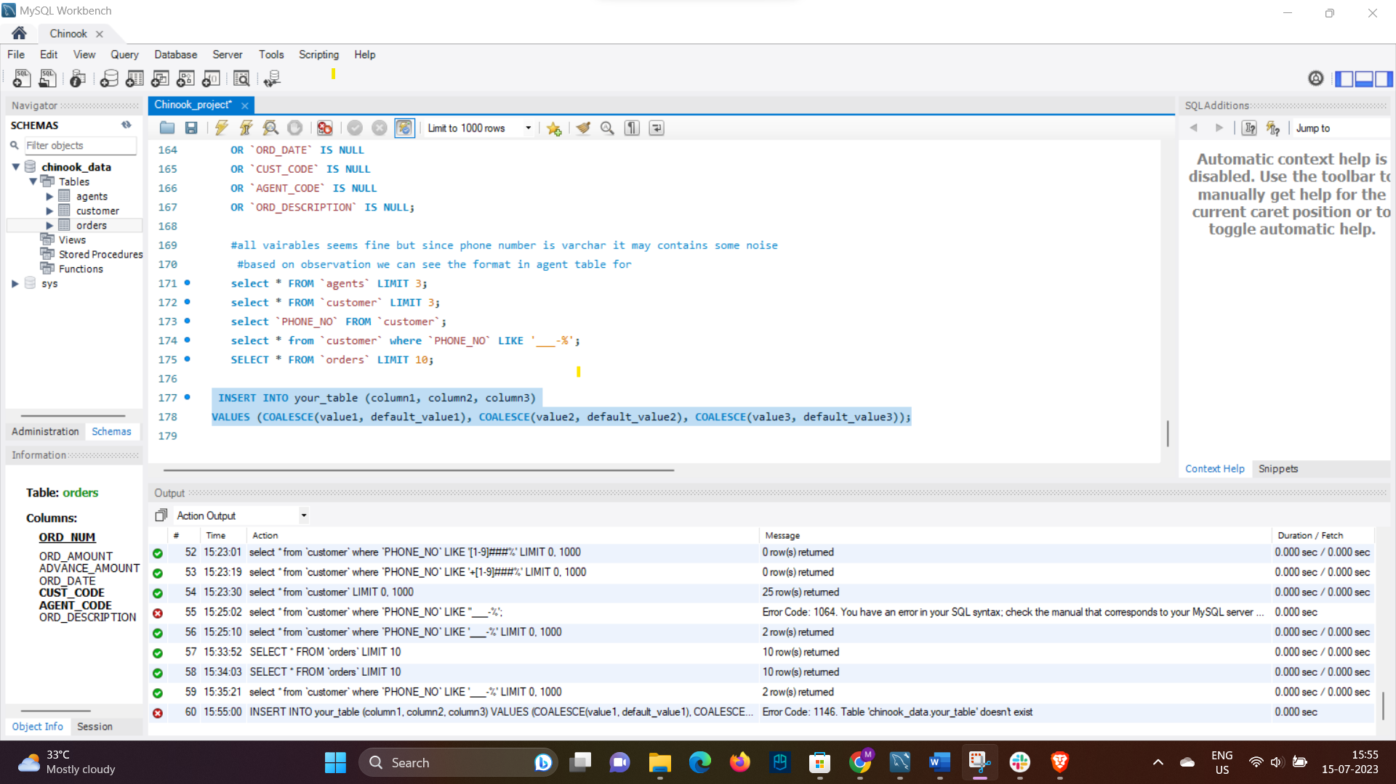

Figure we can change insert query so that there some deafult value attach with user data, so that if something is missing deafult values will be inserted

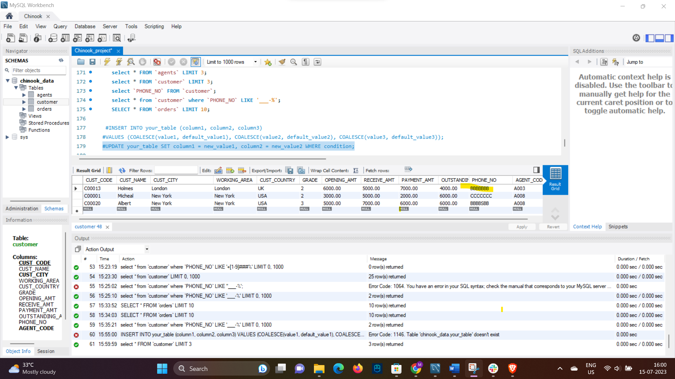

Figure we can update column values, but since it phone and so no action can be done

* Identify any duplicate records within the tables and develop a strategy for handling them.
* By use of proper primary and foreign key patterns we can handle duplicate value.
* For AGENT table we have Agent code as primary key hence we don’t need to check the duplicate values, but most common mistake can happen with phone number, so we will check for duplicate values in phone number:
* 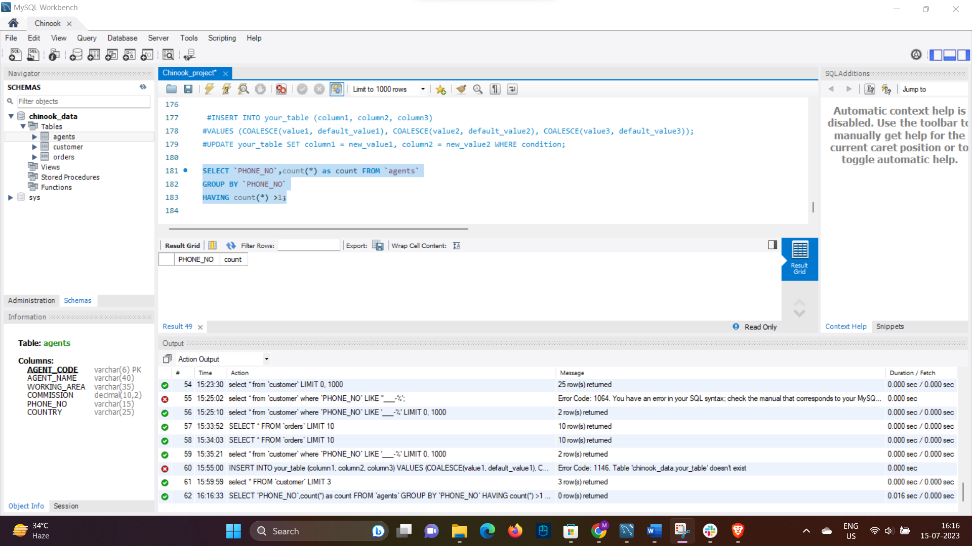

Figure No duplicate entry in agents columns

For customer table since in phone no. column we have garbage values we cannot find out duplicate values with given constraints.

For order table we have 1 primary key and 2 foreign key and rest of columns could have correct repeated value so we deciding not to check for duplicate value for this table also.

# Data missing

Observed one data entry in table order which have agent_code as foreign key which is not having any parent reference in table agent. This was breaking of referential integrity constraint.

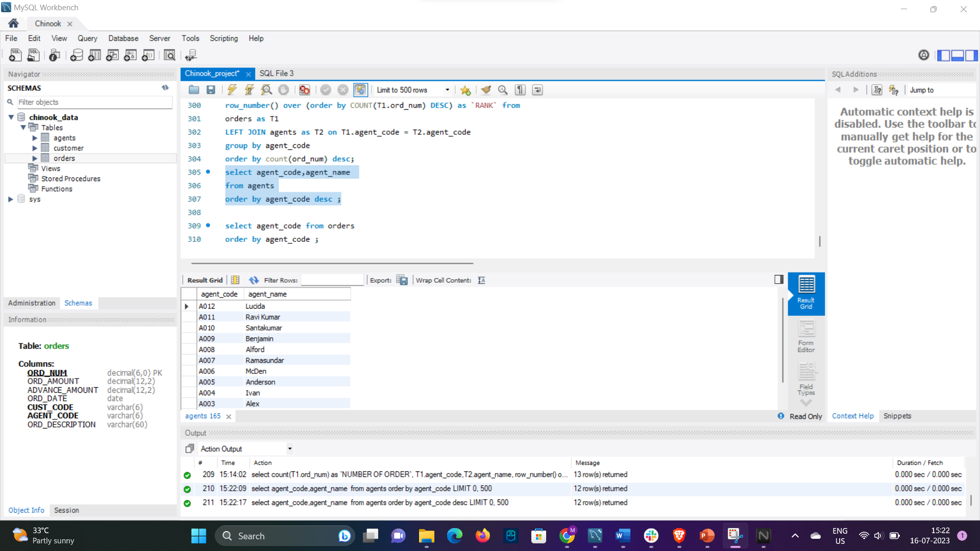

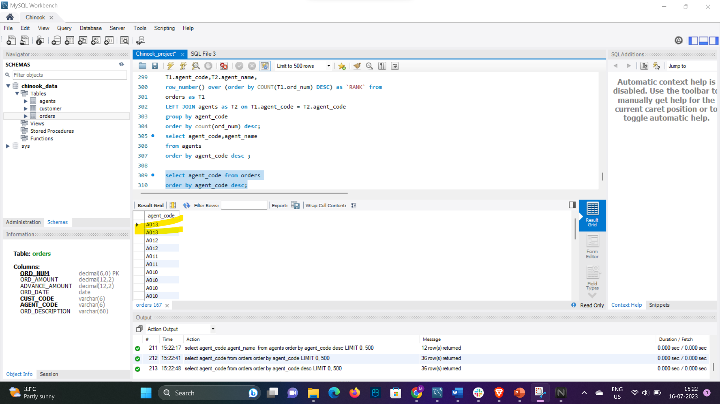A013 values is missing from parent table agent but one entry was there for this agent code in order table.

ASSUMPTION:

1. Value missed in agent table
2. Incorrect agent code entered in order table

Since knowledge about dataset limited, imputing on base of assumption will not be a suitable choice hence leaving these entry as it is.